# Project Exam 1

Andrew Hay

Word count

510

## Links

Prototype

<https://xd.adobe.com/view/7dc38053-32dd-4029-9446-312023cfba0f-2890/>

Final Site

<https://projectexamoneandrewhay.netlify.app/>

## Design

Researching blogs initially for inspiration, I came across a large variety of use cases for blogs. Never really having looked at influencer blogs, that is what I had in mind when I imagine blogs. However I found that independent news, review sites and personal influencing could all be considered blogs and that their website design had evolved a long way from the early 2000’s single page newest post at the top of the page type blogs I was previously more familiar with that look similar to the base layout of a WordPress site. This showed me that from looking at sites like perezhilton.com and mashable.com, considered larger blogs, there are different designs and they have evolved quite a bit from my earlier perception.

I always struggle a bit with designing something usually going for a very simple look and I have not really mastered any fancy css animations yet to make the pages feel more alive.

## Technical

I like using Trello to keep track of my progress and the different steps to complete.

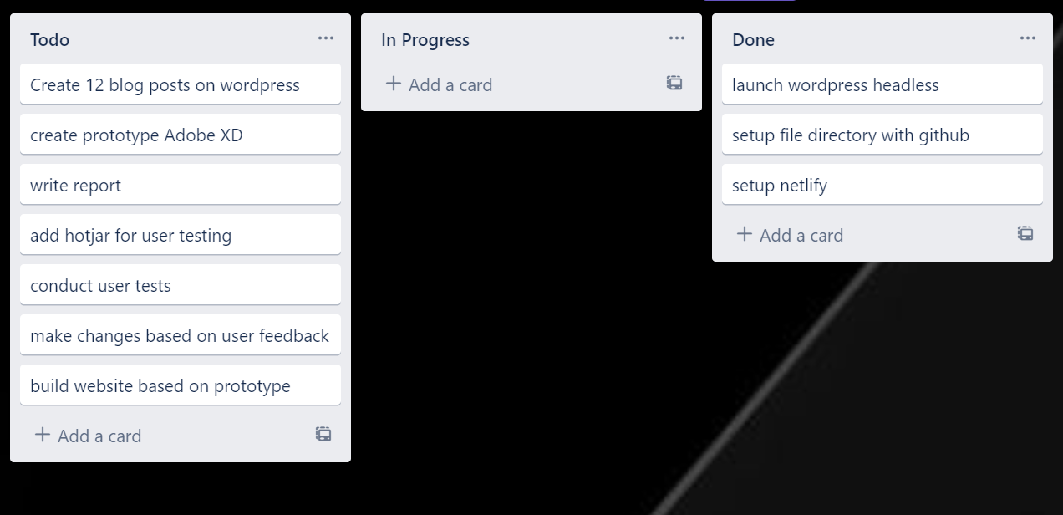

I feel I have a good grasp on reading api json and being able to call upon objects from arrays using loops.

The coding was difficult figuring out how modals and carousels work in the code as well as the fact that WordPress only fetched 10 posts as default confused me to begin with I thought I must have a bug. Fetching images from WordPress was also a bit of a pain that the featured image source was not directly in the post api but was in the media api linked by an ID so matching that was some extra work.

I am still struggeling to think in a module sense and using import and export of functions so I end up with duplicated functions across different js files because I find it easier to make small alterations this way without working across files. But it does become messy and probably causes me more headaches than if I could separate it into multiple files nicely. So working on importing and exporting functions is something I want to do more of.

## WCAG guidelines, content management and SEO

Used WAVE chrome extension and Lighthouse in the chrome developer tools.

Both WAVE and lighthouse noticed a lack of contrast in the footer text so adjusted the blue color.

Before

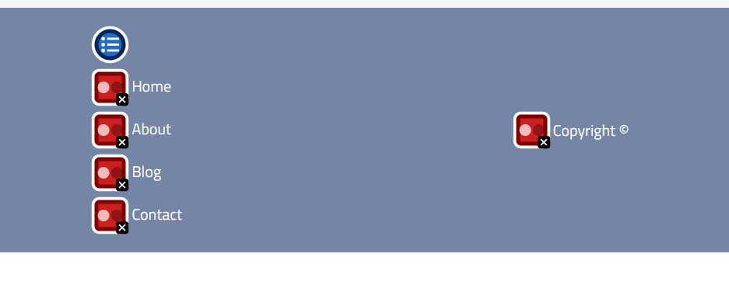

After

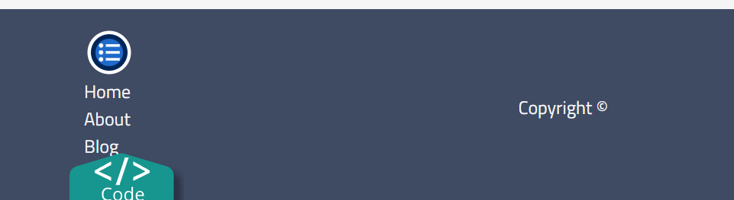

Otherwise I was missing alt text for the logo img.

Conducting user testing there have been no miss clicks and users seem to be able to move around the page well. Due to the nature of loading the posts on the blog page and carousel on each load instance, it does not save the scroll position of the user prior to their return to that page so they need to scroll through or down to their position again. This was the only feedback I have received, and after some googling seems possible to implement by saving scroll position. Either by the page location or on the carousel page to local storage and then resuming position after the data is fetched.

## References

<https://www.w3schools.com/howto/howto_css_modals.asp> I used this page to learn how to make modal

<https://stackoverflow.com/questions/50495815/wordpress-rest-api-more-than-10-posts> had to google to figure out why it wasn’t sending all the posts and how to easily change this